**Appendix A – Circuit Schematic**

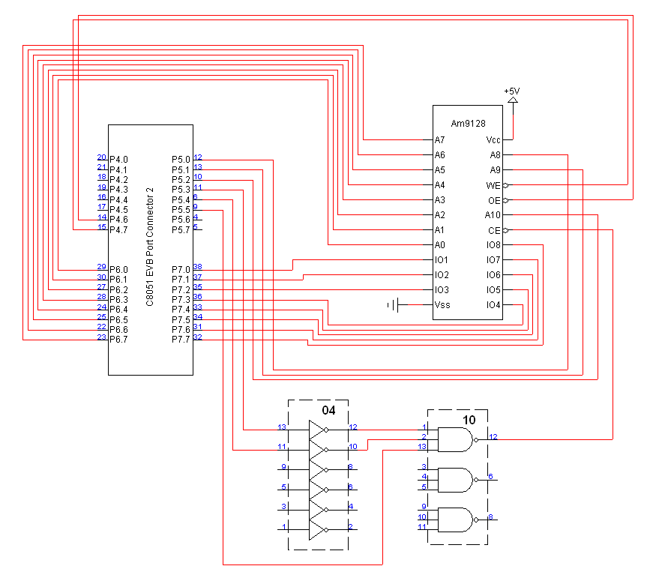

**Appendix B – Circuit Schematic**

